- The index of the outliers removed: 365, 369, 370, 372, 372, 381, 406, 411, 415, 419.
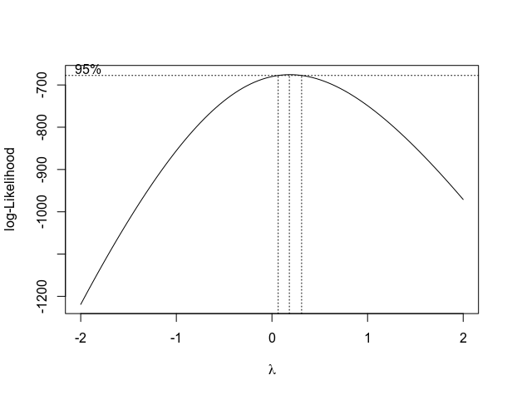
- Following is a box-cox plot of the lambda parameter and its log-likelihood. The best lambda is around 0.182.
Figure 1: The log-likelihood vs. parameter of box-cox transformation.

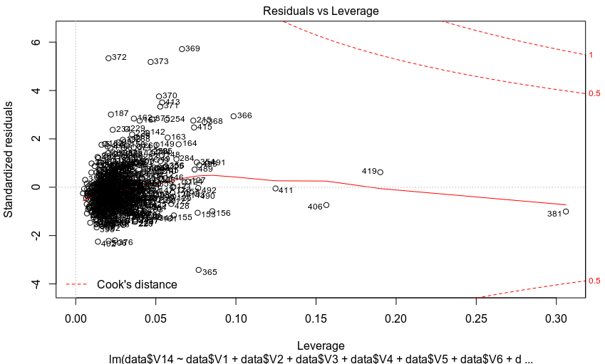
Figure 2: Standardized Residual vs. Leverage vs. Cook’s Distance plot with outliers.

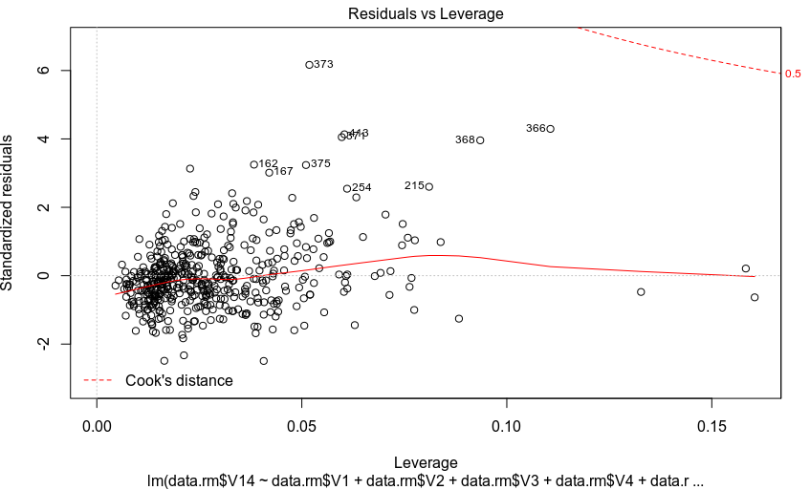
Figure 3: Standardized Residual vs. Leverage vs. Cook’s Distance plot without outliers.

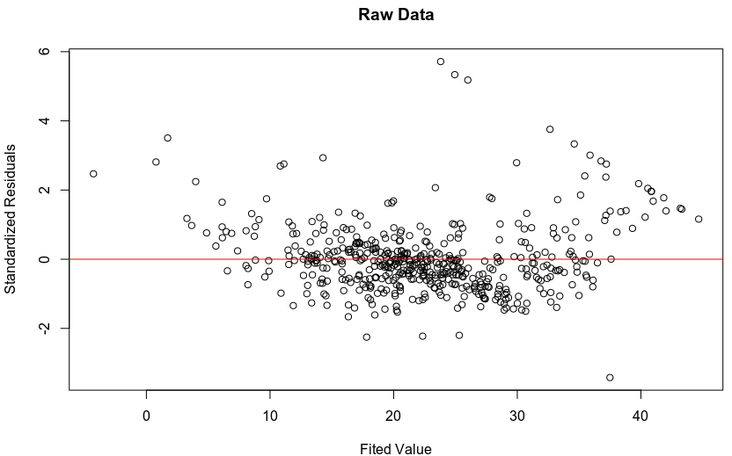
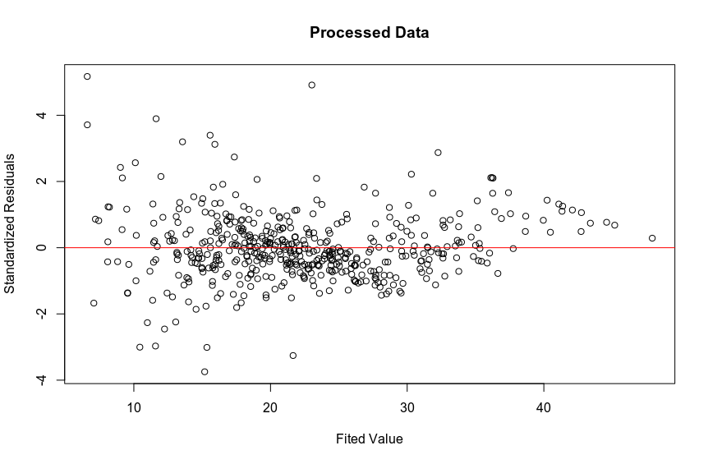
Figure 4: Standardized Residual vs. Fitted Values without transformation
Figure 5: Standardized Residual vs. Fitted Values with transformation (10 outliers removed & transforming the dependent variable)

